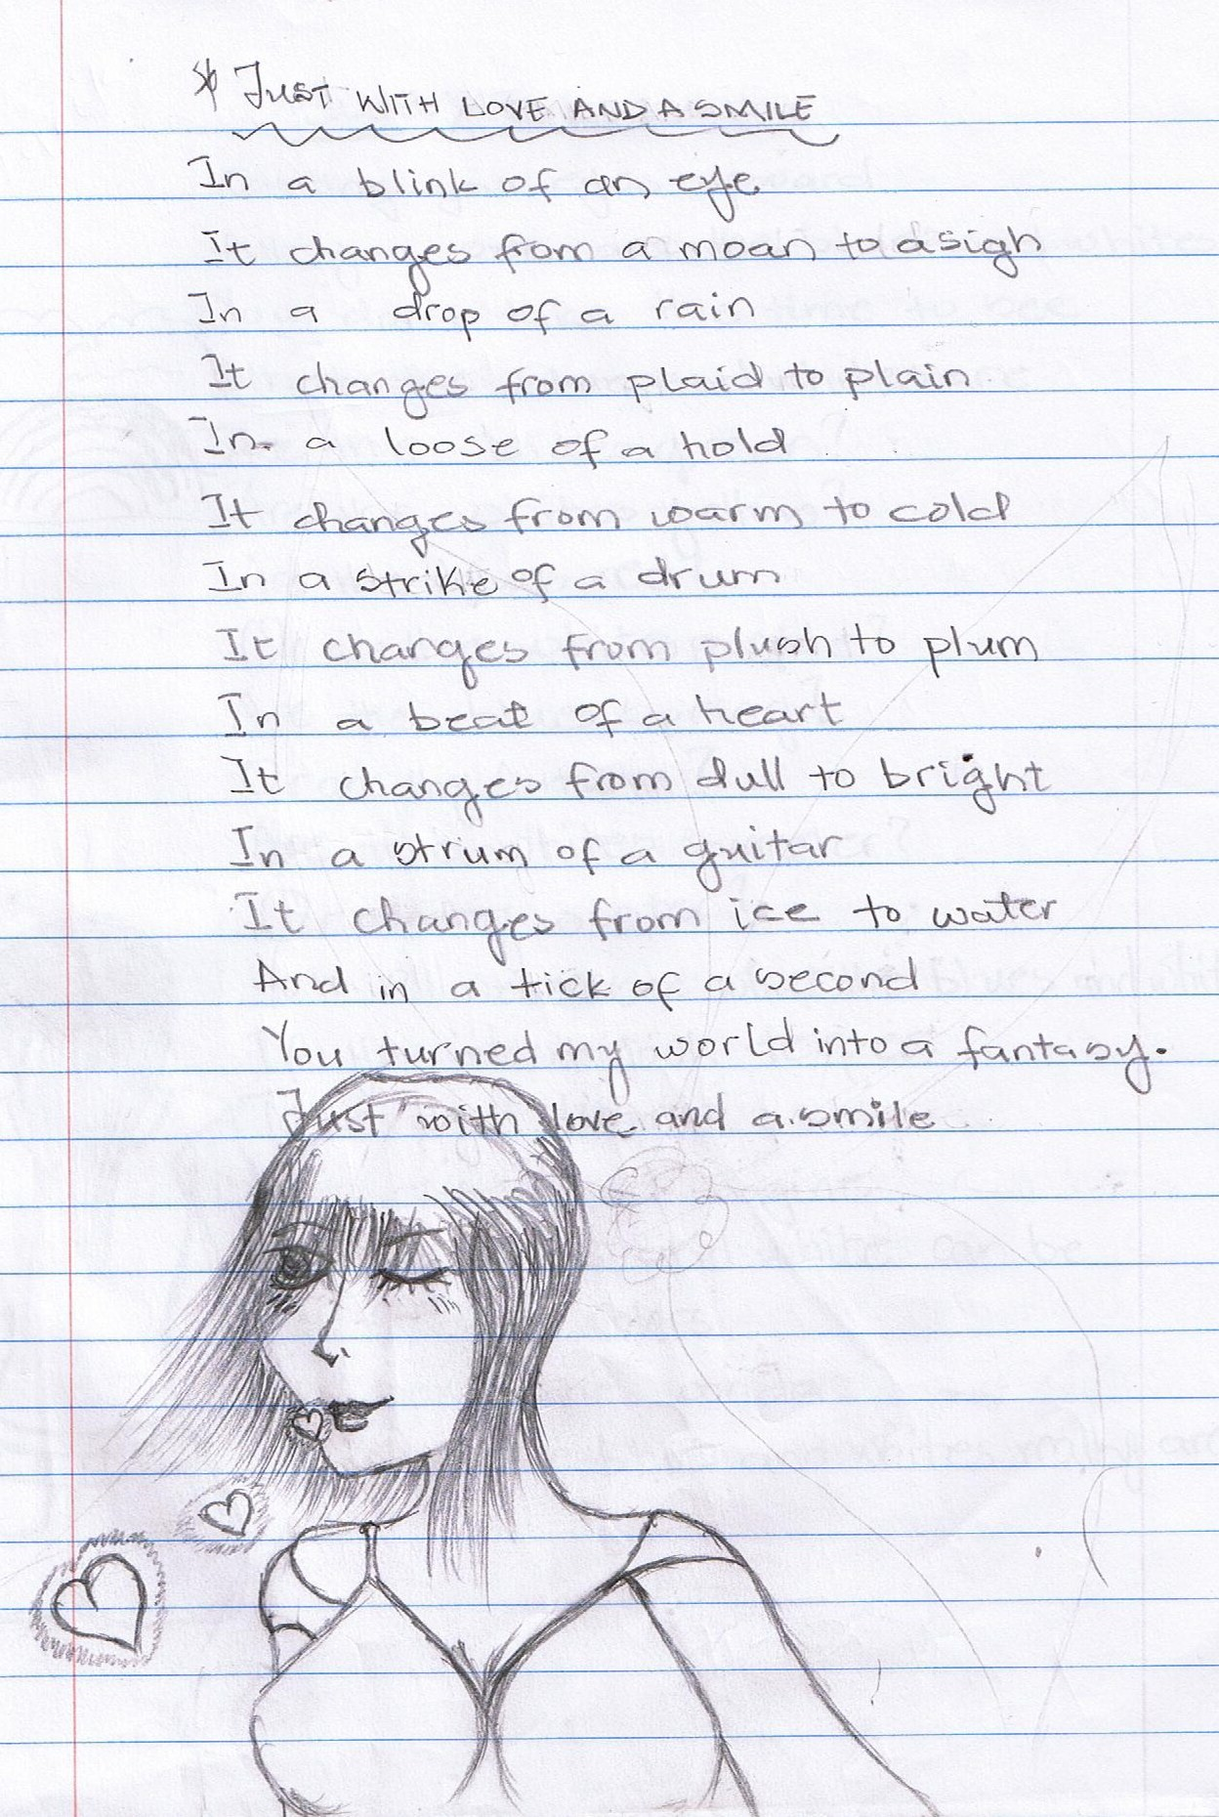

Just With a Smile By Esther Appiah

In a blink of an eye
It changes from a moan
To a sigh

In a drop of a rain
It changes from plaid
To plain

In a loose hold,
It changes from warm
To cold

In a strike of a drum
It changes from plush
To plum

In a beat of a heart
It changes from dull
To bright

In a strum of a guitar
It changes from ice
To water

And in a tick of a second
It changes from an impression
To an expression—
Just with a smile.

